**E-Commerce Website**



**COMPUTER SCIENCE AND ENGINEERING**

**7th Semester , Final Year Project**

**GROUP MEMBERS**

**SUBHADEEP MAJI (10800119037)**

**SNEHA MUKHERJEE (10800119041)**

**MRINAL TANTUBAI (10800119077)**

**AKASH RUIDAS (10800119084)**

**Project Title: E-Commerce Website**

**SYNOPSIS**

Nowadays Purchasing goods and services online has become a common practice among all people around the world. Some choose to make online purchases for convenience, others because of the competitive price offered by several e-commerce platforms all over the year or during the festive seasons. Digital buyers can also be influenced by a range of digital resources when shopping, such as brand emails and product reviews. Regardless of the reasons for purchase, the number of digital buyers is on the rise. Different online payment options are preferred as popular payment methods amongst online shoppers worldwide, as more than 40% of online shoppers affirmed using this method. The traditional credit card ranks second, followed by debit cards. The range of devices with Internet connections available to online shoppers allows products to be purchased almost anywhere from any device. Online shopping is expected to remain popular in the future, as the country is one of the leading online retail markets with prospects to grow in the next years.

**PROJECT MOTTO**

The main aim of the project is to develop a e-commerce website which would allow users to do online shopping with a great variety of products, several fascinating discounts on a yearly basis and as well as festive season sales. There will also be special membership features users with such memberships will be given special offers on a yearly basis and some add-on facilities like fast delivery and so on. There will also be the availability of online payment system as nowadays it is used by people all over the world.

**PROGRESS REPORT**

**Completed pages :**

1. **Home Page** 
   * + - * **Navigation Bar**
         * **Products**

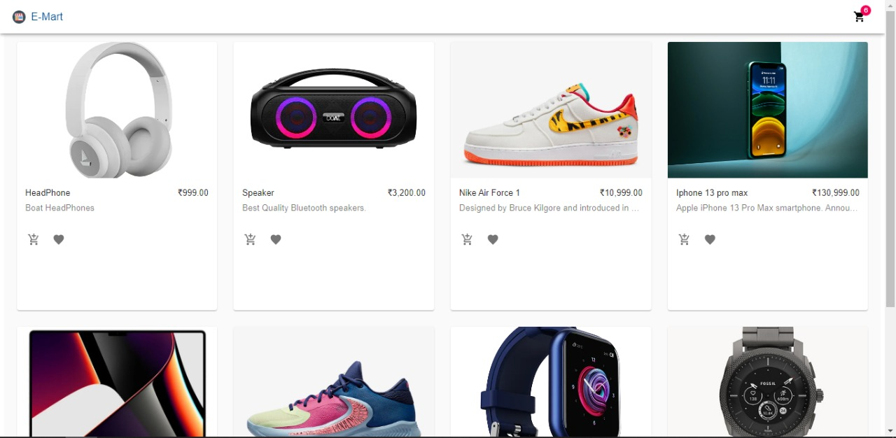

**2. Cart**

* + - * + **Adding and Removing Items from the cart**

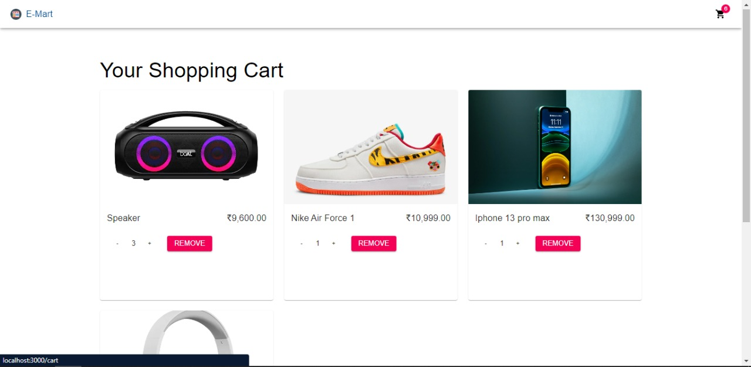

**Front End :**

* + - * + **React Js**

**Back End :**

* + - * + **Commerce Js**

Commerce demo store built for the Jamstack. Built with Commerce.js, Next.js, and can be one-click deployed to Netlify. Includes product catalog, customer login, categories, variants, cart, checkout, payments (Stripe) order confirmation, and printable receipts.

**3. Check Out (In making)**

